

Master Thesis

Building a web-based experiment to capture and analyze cultural attraction

Renan Oliveira Moreira

2019

Eötvös Loránd University

Faculty of Education and Psychology

Master of Science in Computational and Cognitive Neuroscience

Building a web-based experiment to capture and analyze cultural attraction

Author Supervisor

Renan Oliveira Moreira Dr. Christophe Heintz

Student Head of the Department of Cognitive Science at CEU

2019

Declaration of Originality

I declare herewith, that this thesis presented here is my own original work.

Furthermore, I confirm that:

− this work has been composed by me without assistance;

− I have clearly referenced in accordance with departmental requirements, in both the text and the bibliography or references, all sources (either from a printed source, internet or any other source) used in the work;

− all data and findings in the work have not been falsified or embellished;

− this work has not been previously, or concurrently, used either for other courses or within other exam processes as an exam work;

− this work has not been published.

I appreciate that any false claim in respect of this work will result in disciplinary action in accordance with the university or departmental regulations.

I confirm that I understand that my work may be electronically checked for plagiarism by the use of plagiarism detection software and stored on a third party’s server for eventual future comparison.

Renan Oliveira Moreira February 04th, 2019

Proof of consultation, supervisor’s statement

page should contain a confirmation form which contains the supervisor's consent for thesis submission

ACKNOWLEDGEMENTS

Abstract

Keywords

## Table of Contents

Abstract I

Keywords II

Table of Contents III

List of figures V

List of tables VI

Abbreviations VII

Part I: Background 1

1. Introduction 1

1.1 Motivation of the research 2

1.2 Research aim and objectives 2

1.3 Research question 3

1.4 Research approach 3

1.5 Thesis structure 4

2. Theoretical foundations 4

2.1 Culture transmission 4

2.2 Cultural Attractor Theory 6

Part II: Experiment / Empirical studies 8

3. Design 8

3.1 Architecture 8

3.1.1 Angular framework 9

3.1.2 Firebase hosting and database structure 9

3.2 Scenarios for testing 12

3.2.1 Calibration 13

3.2.2 Face 14

3.2.3 Spiral 15

3.2.4 Button 16

4. Data collection 16

4.1 Calibration phase 17

4.2 Testing phase 17

4.3 Attractor condition phase 17

5. Data analysis 18

5.1 Algorithms 18

Part III: Conclusion 19

6. Discussion and future work 19

6.1 Research objectives: Summary of findings 19

6.2 Limitations 19

6.3 Future research 19

References 20

List of figures

Figure 1 - Data structure OF cloud firestore. source: https://firebase.google.com/docs/firestore/images/structure-data.png 10

Figure 2 - DATA STRUCTURE EXAMPLE FROM THE EXPERIMENT. SOURCE: ELABORATED BY THE AUTHOR. 11

Figure 3 - Face shaped image used on the scenario 14

List of tables

Table 1 - Detailed explanation of data variables 12

Abbreviations

Pixels px

CAT

IT

Part I: Background

# 1. Introduction

The word culture can draw multiple interpretations or even meanings for each of us, but some of the most accepted and well-marked definitions can be seen in the Merriam-Webster dictionary as: “the customary beliefs, social forms, and material traits of a racial, religious, or social group” or “the integrated pattern of human knowledge, belief, and behavior that depends upon the capacity for learning and transmitting knowledge to succeeding generations” (Merriam-Webster Dictionary, 2018). These two definitions together offer a great idea of what is culture and how it is vital in our life.

Focusing on the second definition, it offers a valuable content that cannot be overlooked and still up to debate in the scientific community, more specifically when it refers to “...learning and transmitting knowledge to succeeding generations”. This part is extremely important and will be main topic of discussion of the theoretical approach of this thesis. Touching some topics as: How is culture transmitted? What are the mechanisms that affect the process of transmission? Draw a parallel of culture transmission with genetic transmission, memetics, the cultural evolutionary theory, and more specifically one of those approaches within the cultural evolutionary theory called cultural attraction.

With purpose of exploring deeper the Cultural Attractor Theory (hereafter; CAT), it was created a web-based experiment which allowed multiple users around the world to interact with different hypothesis and scenarios regarding cultural attraction. Those interactions resulted on small amount of data that was analyzed with the goal to find any patterns that could be assumed as a factor of attraction. The whole creation of the experiment and the analysis of the results will be elicited in the empirical part of this thesis.

## Motivation of the research

My Information Technology background studies and working experience drove me to the construction of the website and the utilization of Machine Learning algorithms to analyze data, together with my interests in social sciences, pushed me to develop the research on this topic so interesting called cultural evolution and more specifically cultural attractor theory which is currently discussed in the scientific community and has plenty of flourishing ideas and controversies. One of the controversies for example is considering memes as the unit of human cultural transmission, other example, regarding CAT, is the dilemma found on the article from (Claidière & Sperber, 2007) called “The role of attraction in cultural evolution” which defends a probabilistic view of cultural attraction that it was firstly introduced by (Sperber, 1996), against a deterministic interpretation of cultural attraction proposed by (Henrich & Boyd, 2002) .

## Research aim and objectives

The aim of this research project is to create a web-based experiment that enables testing hypothesis related to CAT, more specifically, a cross selection game that has different scenarios to try out which of those scenarios could be factors of attraction. Besides the construction of the website, it will be collected data for a certain period of time, more precisely 3 months and 10 days, that will be used in the data analysis with the hope of finding any result that could lead us to concluding the presence or existence of factors of attraction on these tested scenarios.

Besides my own data collection and data analysis, the platform of the experiment was constructed with the aim to be made available to other researchers and scientists interested on the topic. The code of the whole website structure is open source and available to be use by everyone, so the only required steps for the utilization would be the modification of the desired tested scenarios and deploying the website. With this approach of adopting open source development, there is the aim of sparking a discussion about the topic and providing a platform where other researchers could test their own hypothesis and leverage on the website.

## Research question

Question the existence of some factors of attraction on possible scenarios.

## Research approach

(Verschuren & Doorewaard, 2010) describes five ways to conduct a research: a survey, an experiment, a case study, a grounded theory approach and desk research. It was adopted the experiment approach because it was desired to compare two different groups of scenarios, one containing possible factors of attraction and other without it, and check the validity of one hypothesis, in our case, the existence of factors of attraction in some specific scenarios. Talk about web-based experimnent a lot. Standards for Internet-Based Experimenting, Ulf-Dietrich Reips. 2002.

This master thesis research can be separated in three stages of development: the first one was the exploratory literature studies about CAT and the planning and designing of the experiment. The second stage consisted on the coding and deployment of the website and the third and last one was the data collection, extraction, analysis and conclusions.

First stage: In-depth literature studies were fulfilled to enable the understanding of the research. Those studies together with discussions with Cristopher Heintz made possible the elaboration of the design of the experiment. On this phase, it was also decided which programming language would fit the requirements and would be adopted in the project implementation, Angular 5, details on the decision will be explained on the section 3.1.1 Angular Framework. It was also necessary technical studies regarding web programming, more specifically TypeScript, programming language used by the Angular Framework. This phase on lasted approximately 4 (four) months, from May of 2018 until August of 2018.

Second stage: The implementation, also known as coding of the website, used as the platform for the web-based experiments lasted for approximately 6 (six) months from August of 2018 until January of 2019. This phase also contained the creation of the necessary connections to access the database (Cloud Firestore) and the deployment of the website on the Firebase platform, the details of this will be later explained on the section 3.1.2 Firebase hosting and database structure.

Third stage: The last stage of the development of the research is the de facto experiment, when the web-based experiment in online and accessible to the users, allowing the collection of the data. This collection period lasts for 3 months, from X to Y and after that, the data extraction from the database and analyses of the data is performed. In parallel with those tasks, this master thesis which provides the documentation of the research was being written.

## Thesis structure

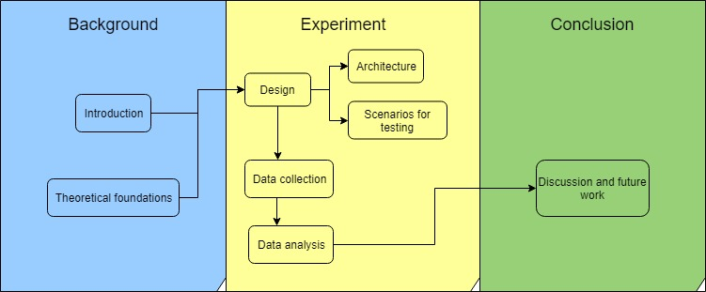The structure of the thesis follows the instructions from the thesis manual from ELTE PPK, which recommends the separation of the structure into Theoretical and Empirical part as can be seen in the Figure X:

# 2. Theoretical foundations

## 2.1 Culture transmission

Cultural transmission is the transmission of preferences, beliefs, and norms of behavior as result of human beings interacting across and within generations [1].

[1] Bisin, B., Verdier, T. (2005). Cultural Transmission. The New Palgrave Dictionary of Economics 2, 2008.

Vertical transmission (genetic transmission) vs oblique transmission (social learning).

There are problems associated with any effort to trace the pedigree of cultural evolutionary theories back to Darwin himself. One of the reasons for this is that cultural evolutionary theories often define themselves in opposition to those which claim that genetic inheritance is the only significant inheritance mechanism. Clearly one cannot cast Darwin as a cultural evolutionist in this manner, for he had no notion of genetic inheritance to oppose. Having said this, Darwin did believe that what was learned in one generation could be inherited in later generations. But far from distinguishing cultural inheritance from organic inheritance, Darwin thought that all inheritance should be explained by the transmission of ‘gemmules’.

Fathers: Herbert Spencer and Charles Darwin – cultural evolution

Work of Lumsden and Wilson (1981), Cavalli-Sforza and Feldman (1981), and Boyd and Richerson (1985). All of these authors have attempted, in one way or another, to produce formal models that can integrate the effects of cultural inheritance into more standard biological models of evolution.

Dan Sperber (1996), Richerson and Boyd 2005

Difference between genetics vs culture: These sorts of cultural evolutionary models do not assume that cultural inheritance works in the same way as genetic inheritance. Yet they remain recognisably evolutionary in style, primarily because they seek to explain the changes in trait frequencies in a population over time.

No one can deny that cultural inheritance is an important factor in explaining how our species has changed over time. Cultural inheritance is not merely a process that acts in parallel to genetic evolution, it is intertwined with genetic evolution.

Importance of culture: Cultural changes bring about alterations to the environment, which in turn affect both how genes act in development, and what selection pressures act on genes.

Should I Talk about memes? *Cultural units are not replicators*: Attractor vs Replicator. Attractor - culturally shared patterns of thought, which enable representations to spread through a population without literal copying.

… most cultural items are ‘re-produced’ in the sense that they are produced again and again—with, of course, a causal link between all these productions—but are not reproduced in the sense of being copied from one another…Hence they are not memes, even when they are close ‘copies’ of one another (in a loose sense of ‘copy’, of course). (Sperber 2000, 164–65)

Cultural evolutionary Theories: We want to know what makes some ideas fitter than others. in the cultural realm we will need to look at local psychological dispositions to explain why some ideas are more likely to spread than others.

5 theories that can be put together

<https://plato.stanford.edu/entries/evolution-cultural/#ExpRolCulEvoThe>

Five Misunderstandings about Cultural Evolution (2002) Joseph Henrich, Robert Boyd and Peter J. Richerson: Second, Sperber (1996), Atran (2001) and Boyer (1998) emphasize that unlike genes, ideas are not transmitted intact from one brain to another. Instead, the mental representations in one brain generate observable behavior, a “public representation” in Sperber’s terminology

Mental representations will be replicated from one brain to another only if most people induce a unique mental representation from a given public representation. Moreover, inferential processes often systematically transform mental representations, so that unlike genetic transmission, the cultural transmission is highly biased toward particular representations. Following Sperber (1996), we call the representations favored by processes of psychological inference (including storage and retrieval) ‘cognitive attractors.’

cognitive attractors will rapidly concentrate the cultural variation in a population. Instead of a continuum of cultural variants, most people will hold a representation near an attractor. If there is only one attractor, it will dominate. However, if, as seems likely in most cases, attactors are many, other selective forces will then act to increase the frequency of people holding one attractor and decrease others. The weak selective forces (‘weak’ relative to the strength of the attractors) will actually determine the final distribution of representations in the population.

In the formalization, individuals acquire their mental representations by observing the behavior of others. Two cognitive mechanisms affect this learning process. First, inferential transformation captures the manner in which cognitive processes of acquisition, storage and retieve alter mental representations in ways to favor some representations over others—cognitive attactors. Because the two extreme represetations, “Moon as person“ and “moon as rock“ are easier to think, they act as cognitive attractors in our example. Individuals who observe behaviors that result from intermediate representations tend to infer mental representations closer to one of the two attractors. The second process, selective attention, captures the tendency for individuals to pay particular attention to some individuals more than others. For example, it could be in a modernizing environment, where the representations favored by science are prestigious, people who hold the “moon as rock“ representation are more succesful than those who hold the alternative, and thus they attract more attention (and are more likely to be learned from). Finally we assume the effects of inferential transformation are much stronger than the effects of selective attention.

## 2.2 Cultural Attractor Theory

One of the models to explain the process of cultural evolution is Cultural Attraction Theory (CAT) which differs from other evolutionary approaches as it develops the idea of constructive convergence in cultural transmission [2]. Constructive convergence refers to processes of cultural transmission that cause systematic transformation rather than faithful replication of cultural items. However, the transformations are biased and favour the production of some cultural items. These transformation biases can be explained by the existence of factors of attractions, which stabilize the distribution of cultural items at a macro level (whole populations and across generations) [3].

[2] Heintz, C. (2017) Cultural Attraction Theory. International Encyclopedia of Anthropology, Wiley Online Library.

[3] Claidière, N., Sperber, D. (2007). The role of attraction in cultural evolution. Journal of Cognition and Culture 7 (2007)

89-111.

Attraction can have Cognitive disposition, but also psychological or environmental. And it can change over time depending on the factor…but slowly

Attraction vs selection

2.3.1 Determistic

2.3.2 Probabilistic

Part II: Experiment / Empirical studies

# 3. Design

Explain somehow, how the cross clicking could be interpreted as cultural transmission, cognitive process.

The design of this project is a result of a collaborative work and ideas between the supervisor of the project and head of the Cognitive Science department of the Central Eastern University, Dr. Christophe Heintz and myself, student graduating at the Master of Science program of Computational and Cognitive Neuroscience at the Eötvös Loránd University.

Due to the deeper and wider knowledge of Cultural Attraction Theory and the longer history on the field of Cognitive Science, the conditions tested on this experiment are a creation from Dr. Heintz ideas. The implementation of the project, which contains: development and deployment of the website are result of my expertise on the field of Information Technology, due to my Bachelor in Computer Science and work experience on the aforementioned area.

On the following chapters, it will be detailed the architecture of the website, including the technical aspects of it, and the conditions tested, the reasoning behind each of them, and how they are related with the theory of factors of attraction. The code of the website won’t be presented nor explained on this paper because it’s not the aim of this project approaching the nuances of computer programming, but rather test the Cultural Attractor Theory using a web platform which enables high availability and collection of data. That said, the code has comments in itself with the goal to facilitate the understanding of anyone interested on it and it is available on the personal GitHub repository of the author of this Master’s Thesis. That can be accessed at: https://github.com/RenanOm92/factorsAttractionFirebase.

## 3.1 Architecture

Talk about the screens (home screen, instructions, start screen, fill-out, feedback screen, results screen)

### 3.1.1 Angular framework

The project was developed using the framework Angular, which provides the possibility of creating applications compatible with cross platforms (web, mobile web, desktop)[insert reference <https://angular.io/>], fulfilling one of the aims of the design of the experiment which was having a website accessible by every type of user, at any moment, from anywhere. Generating this way, a spreader sample of whom would interact with the website, deeply connected with our goal that is to examine culture transmission, meaning that the bigger the reach of the experiment, the more accurate would be the conclusions draw by it.

Angular is also an open source project led by Google and the community, which provides a great and stable environment for development, but at the same time still being updated with new features and being one of the most popular Frameworks for web development [insert reference <https://hackernoon.com/is-the-angular-decline-a-myth-e4cf563b72d6>]. Another important advantage of Angular it’s the two-way data binding feature, which enables the Model and the View being synchronized, allowing them to communicate between each other and any changes on the data would affect the visualization of it, used on the project for the calculation of the random position of the cross visualized in the start of each round.

With all these qualities listed above, Angular was chosen as the framework used for constructing the website of the experiment. The version utilized was Angular 5, which has released date on November 1st of 2017. [insert references]

### 3.1.2 Firebase hosting and database structure

Firebase is a multifunctionality platform owned by Google which provides a large range of products, including hosting and database integration to web applications which were necessary for the deployment of this experiment. [insert reference <https://firebase.google.com/>] Firebase was the chosen platform because it offers a free plan with the following specifications, which covers all the needs of the project: hosting the web application, 100 simultaneous connections, saving the data on a database with a limit of 1 *Gigabyte* per month, extracting the data from the database and custom domain. For the reasons listed above, the website was then hosted on Firebase with the domain name: factorsattraction.firebaseapp.com. And all the data collected from the experiment was saved on the Cloud Firestore Database accordingly with the data structure supported: Collection, Document, Data as shown on the Figure 1.

Figure - Data structure of cloud firestore. Source: https://firebase.google.com/docs/firestore/images/structure-data.png

The experiment was released in different phases, as it will be explained on the section 4. Collecting data phases, and it each phase was saved as Collections using the semantic versioning approach [insert reference <https://blog.codeship.com/best-practices-when-versioning-a-release/>]. Each interaction of the user (also called as one round) it was saved as a Document with ID generated randomly by Firebase, and all the data referent to the round was saved inside the document. Each document on the final phase of the project had the following structure of data: *condition*, *coord_original_left*, *coord_original_top*, *coord_user_left*, *coord_user_top*, *device*, *email*, *screenSize*. The database structure can be seen on the Figure 2.

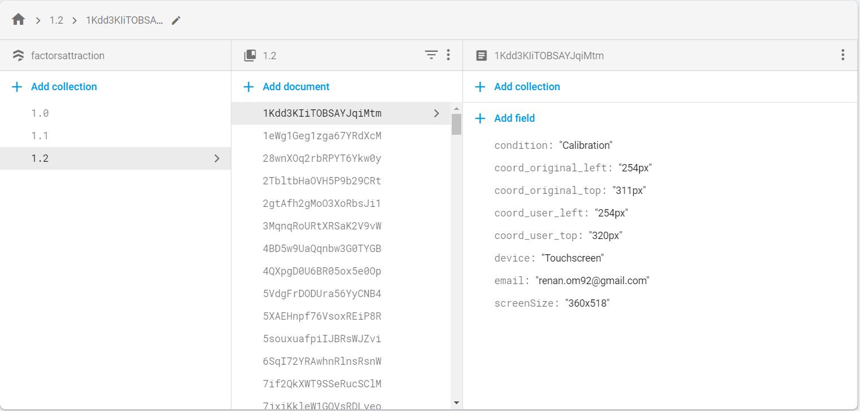Figure - Data structure example from the experiment. Source: Elaborathed by the author.

The meaning of each field value is better explained on the Table 1 below:

|  |  |  |
| --- | --- | --- |
| Field | Description | Type of data and exemplification |
| Collection | Container of the document. Used for control of version. | Numbers on the format:  1.1  2.0 |
| Document | Unit of storage, represents one interaction of the user playing the experiment. It’s an unique sequence of 20 characters composed of letters or numbers generated randomly by Firebase. | Sequence of 20 letters or digits:  1Kdd3KIiTOBSAYJqiMtm  4BD5w9UaQqnbw3G0TYGB  4QXpgD0U6BR05ox5e0Op |
| Condition | Represents the possible conditions in which the experiment can be played. | One of the following values:  Calibration  Face  Spiral  ClickHereBottomLeft  ClickHereTopRight |
| coord_original_left | Represents the horizontal position on pixels which the cross was displayed at the beginning of the experiment. Where the 0 value is the left of the screen. | Number followed by pixel:  746px |
| coord_original_top | Represents the vertical position on pixels which the cross was displayed at the beginning of the experiment. Where the 0 value is the top of the screen. | Number followed by pixel:  520px |
| coord_user_left | Represents the horizontal position on pixels which the cross was answered by the user. Where the 0 value is the left of the screen. | Number followed by pixel:  777px |
| coord_user_top | Represents the vertical position on pixels which the cross was answered by the user.. Where the 0 value is the top of the screen. | Number followed by pixel:  12px |
| device | Contains which type of input device was used by the user. | One of the following values:  Touchscreen  Mouse |
| email | Contains the e-mail of the participant, used with the purposes of controlling the number of total interactions versus total of users. | Any possible value containing the e-mail format:  aaaaaa@aaaa.aaa |
| screenSize | Stores the value of the screen size of the device in which the participant used for starting the experiment. | Number x Number:  1366x626 |

Table - Detailed explanation of data variables

## 3.2 Scenarios for testing

## 

When playing the game, the user can experience seven unique and different scenarios, they are: calibration, face, spiral centralized, spiral on the top right, spiral on the top left, “click here” button on the top right and “click here” button on the bottom left of the screen. Those scenarios will be detailed and explained in the following chapters. The scenario on which the user will play the game is randomly generated before the round starts (on the screen containing the instructions of the experiment in case of being the first round or at the end of the experiment for any rounds after that).

Even though the scenarios are randomly assigned, it was created a weighted value of appearance for each of them, with the purpose to have more appearance of a desired scenario. In the tested design, the weights were the selected ones: 33.3% for face scenario, 33.3% for the spiral scenario, 22.2% for the “click here” button and 11.1% for the calibration scenario. The calibration scenario has a lower weight because it was collected calibration data in previous phases, meaning that it wasn’t necessary expose this scenario with the same frequency. And the “click here” button has a slightly lower weight due to the fact that it has only two variances, in contrast with the spiral that have three.

### 3.2.1 Calibration

The calibration scenario was the first stage of the software development and contains the core of the experiment, and it also has the purpose of being a calibration for the following scenarios, meaning that the data collected with this scenario can be used as our control group to further comparisons, this is possible because the calibration scenario don’t have any figure or image that could have a role of being a factor of attraction.

The calibration scenario consists of a white background at the start page and feedback page with a black fill-out screen between them. The start page contains the original position of the cross and it is displayed for one second. Then automatically it is displayed the fill-out screen for half second and then the feedback page can be visualized until the user inputs some value for the cross.

The original position where the cross can be displayed at the beginning of the experiment is generated randomly but it follows some conditions and one parameter. The conditions that it must follows are: not being too close to the edges of the screen, nor being in the center. The cross cannot be in the center due to the appearance of the button “play again” on the center of the results page, which could lead the button to cover some results.

The parameter for calculation of the position of the cross is the screen size of the device of the user. Due to the reason that each user can have different devices (mobiles, personal computers, tablets) with different screen resolutions, it is necessary to capture the screen size on which the user is playing and then based on that, generate the original position of the cross.

Based on that two information, the original position of the cross is a random value in pixels between 5% of the screen size until 45% or 55% until 95% (for both height and width independently). For example, if the screen resolution is 2000 × 1000 pixels (width × height), the possible values for the width would be from 100px until 900px, and from 1.100px until 1.900px and for the height would be from 50px until 450px and from 550px until 950px.

### 3.2.2 Face

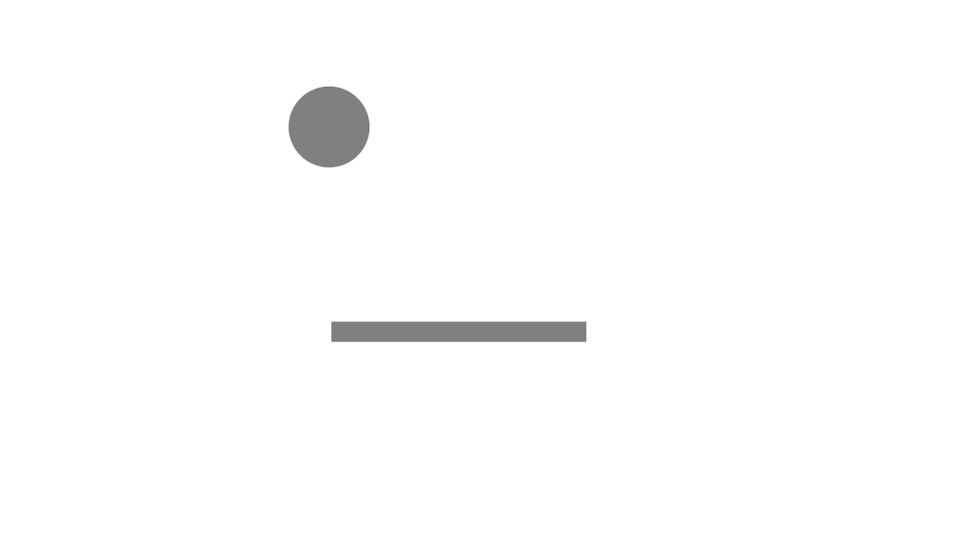The face scenario has the same features of the calibration but with the addition of a background image in the start page and feedback page, this image (figure X) has the intention of recalling the shape of a face with a missing eye. The purpose of this scenario is to try out the hypothesis that the missing eye could be a factor of attraction. Due to the reason

Figure - Face shaped image used on the scenario

The face shaped image is always centralized on the screen and has the feature of missing the right eye. The size of the image is adjustable and relative to the size of screen, which means that the figure does not have a fixed value in pixels, so our analysis of the feedback of the cross need to be based on percentage of the screen size of each user, so in this way we are able to examine if the feedback of the user is located in an approximate position of the missing eye of the shaped face figure. With that said, the center of the missing eye position figure (a hypothesized factor of attraction) is approximately on the coordinates 55% from the left and 27% from the top screen sizes.

Due to the position of the face and more specifically the missing eye being centered, I guided the generation of the random cross position to be more centered also. While the conditions of the cross position on the calibration scenario is being between 5% and 45% or 55% and 95%, in the scenario of the face, it was defined as between 30% and 49% or 51% and 70%. With these limits, the occurrence of the cross position on the center will be higher than in the calibration phase. At the moment of the design, I believed it was worth generating values between 45% and 49% and 51% to 55%, meaning that the cross position could be further covered by the “Play again” button, affecting the usability and user experience quality but would increase the total of valuable samples for data analysis.

### 3.2.3 Spiral

The spiral scenario like the previous one is an extension of the calibration, but it has the addition of showing a spiral on the fill-out screen for 0.5 seconds, this spiral (figure X) has three different variances, based on the location where it can appear (top-left, centralized or top-right) on the screen. This scenario has the purpose of to try out if the center of the spiral could be a factor of attraction. Due to the reason



Figure X

### 3.2.4 Button

The button scenario is also based on the calibration, but it has the addition of a button on the fill-out screen which is necessary to be clicked to proceed with the experiment, this feature is different from all other scenarios, in which the fill-out screen is showed for 0.5 seconds then automatically the feedback screen is shown. The button (figure X) has two different variances, based on the location (bottom-left and top-right) on the screen. The possible factor of attraction tested on this scenario would be the button itself. Due to the reason



Figure X

# 4. Data collection

The website started gathering data on the day XX of December of 2018 and is available until the present day, but at XX of April of 2019 it was taken a snapshot of the database and this specific day will be the last date in which the data will be used for analysis.

## 4.1 Calibration phase

## 4.2 Testing phase

## 4.3 Attractor condition phase

# 5. Data analysis

## 5.1 Algorithms

Part III: Conclusion

# 6. Discussion and future work

## 6.1 Research objectives: Summary of findings

## 6.2 Limitations

## 6.3 Future research

ANALYSIS: USER_LEFT - ORIGINAL % SCREEN SIZE - POSITIVE MEANS: MORE LEFT

NEGATIVE MEAN MORE RIGHT

USER_TOP - ORIGINAL % SCREEN SIZE - POSITIVE MEANS MORE TO TOP

NEGATIVE MEAN MORE BOTTOM

LOOK SPECIFICALLY EACH QUADRANT

# References

Claidière, N., & Sperber, D. (2007). The role of attraction in cultural evolution. *Journal of Cognition and Culture 7*, 89-111.

Henrich, J., & Boyd, R. (2002). On Modeling Cognition and Culture. *Journal of Cognition and Culture 2.2*, 87-112.

*Merriam-Webster Dictionary*. (2018, March 11). Retrieved from Culture: https://www.merriam-webster.com/dictionary/culture

Sperber. (1996).

Verschuren, P., & Doorewaard, H. (2010). *Designing a Research Project.* The Hague: Eleven International Publishing.

Reference list

* Five Misunderstandings about Cultural Evolution (2002) Joseph Henrich, Robert Boyd and Peter J. Richerson.
* Sperber 1996? Find this, cited on introduction

Standards for Internet-Based Experimenting, Ulf-Dietrich Reips 2002